Research and Teaching Collaborators

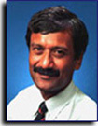
Ravi Shankar, PhD, MBA, PE, Fellow (AHA)
Professor, Computer and Electrical Engineering and Computer Science (CEECS)
Director, Center for Systems Integration (CSI)
Florida Atlantic University (FAU), Boca Raton, FL
Focus: Complex systems and architectures; open source tools and technologies; productivity; and applications of mobile phones, robotics, and semantic web to the fields of education and health.
http://faculty.eng.fau.edu/shankar/
shankar@fau.edu

Professors from various colleges and universities in our current multi-college collaborations on App development with smart phones, robotics and the semantic web (2009-present):

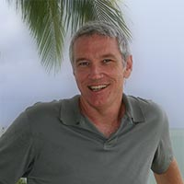
Francis X McAfee, MFA
Associate Professor
School of Communications and Multimedia (SCMS)
Associate Director, Ctr. for Electronic Communications (pre 2007)
College of Arts and Letters, FAU, Ft Lauderdale, FL
Focus: Graphics and Animation
mcafee@fau.edu

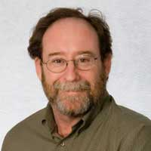
Michael Harris, PhD
Associate Professor and Chair
Department of Anthropology
College of Arts and Letters
FAU, Boca Raton, FL
mharris@fau.edu

Ravi Behara, PhD
Associate Professor
Department of Information Technology and Operations Management (ITOM)
College of Business
FAU, Boca Raton, FL
Focus: Text mining in customer feedback, and healthy aging.
rbehara@fau.edu

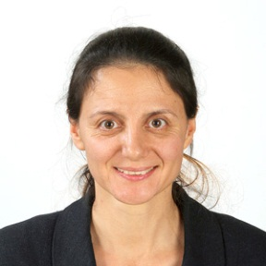
Diana Mitsova-Boneva, PhD
Assistant Professor,
School of Urban and Regional Planning
FAU, Ft. Lauderdale, FL
Focus: Urban planning with sea water rise
http://www.fau.edu/surp/people/
dmitsova@fau.edu

Miguel Alonso, PhD,
Associate Professor and Chair
Electrical and Computer Engineering
Miami Dade College, Miami, FL
Focus: Digital Signal Processing and Minority Education

Steve Hecht, PhD,
Program Professor,
Fischler School of Education
Nova Southeastern University, Miami, FL
Focus: Research strategies for learning and teaching effectiveness

Agnes Nemeth, Math Instructor,
A.D. Henderson University School/FAU High School
Focus: Common core standards for math education
https://sites.google.com/site/fausmath/
anemeth4@fau.edu

Allan Phipps,
District Science Coordinator, A.D. Henderson University School/FAU High School
Focus: Excellence in science and math
aphipps@fau.edu

Don Ploger, PhD
Associate Professor, Teaching and Learning
Focus: Assessment and research strategies for learning and teaching effectiveness
http://www.coe.fau.edu/faculty/ploger/
ploger@fau.edu

Graduate Students from Engineering and Graphics (2009 - Present):

Thomas Vo, MS candidate in CE
Focus: Semantic web and ontology in games

Cynthia Gutierrez, MFA candidate
Focus: Animation and graphics in child nutrition

Steve Wang, MFA candidate
Focus: Data visualization for Big Data.

Miguel Oubina Alvarez, MFA candidate
Focus: Animation for physical therapy and exercise

Frank Wissinger, PhD Candidate in CE
Focus: Hierarchical hydrological model

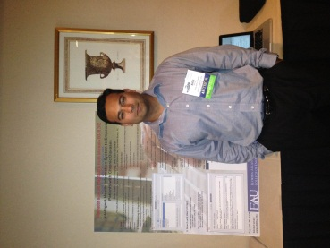
Sifat Islam, PhD candidate in CE
Focus: Semantic web for chronic disease management

Industry Collaborators (2009 - Present):

Jaime Borras,
President, Mobile Technology Consortium (MTC)
http://mtc.fau.edu/

Dean Lyon
CEO, Splinter Studios
http://www.splinterstudios.org/

Norman Silva
Digital Artist and President
Silva Animation Studio, Inc.

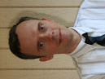
Glenn Freytag
President, Global RNA Inc.,
Focus: Health and education web tools
www.globalrna.com

William and John Ottman
Focus: Open source video archive
http://Minds.org/

Collaborators on the One Pass to Production (OPP) project with Motorola (2003-2008).

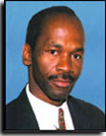
Valentine Aalo, Ph.D.,
Professor, CEECS,
FAU, Boca Raton, FL
Focus: RF and Digital Communications
aalo@fau.edu

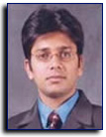
Ankur Agarwal, Ph.D.,
Associate Professor, CEECS,
FAU, Boca Raton, FL
Focus: Network on Chip, Computer Architecture
aagarwa2@fau.edu

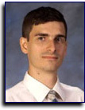
Ionut Cardei, PhD
Associate Professor, CEECS
FAU, Boca Raton, FL
Focus: Sensor and Wireless Networks
icardei@fau.edu

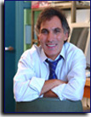
Borko Furht, PhD
Professor and Chairman, CEECS
FAU, Boca Raton, FL
Focus: Multimedia
http://www.cse.fau.edu/~borko/index.html
bfurht@fau.edu

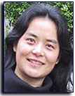
Shihong Huang, PhD
Associate Professor, CEECS
FAU, Boca Raton, FL
Focus: Software Productivity
http://www.cse.fau.edu/~shihong/index.html
shihong@fau.edu

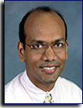
Hari Kalva, PhD
Associate Professor, CEECS
FAU, Boca Raton, FL
Focus: Multimedia and image processing and architectures
Hari.kalva@fau.edu

Imad Mahgoub, PhD
Professor, CEECS
FAU, Boca Raton, FL
Focus: Performance Evaluation
mahgoub@fau.edu

Non-Academic Collaborators for OPP

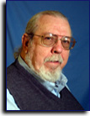 | Dr. Ray Barrett Jr.  Ray Barrett has a PhD from the Electrical Engineering Department, Florida Atlantic University, an MS In CS from Nova University, and is a registered PE in the State of Florida. He has more than 40 years of industrial experience, having worked at Motorola Labs, Boynton Beach and Plantation, FL, as a Senior R&D engineer. He has more than 10 US patents. Email: Rlb004@adelphia.net
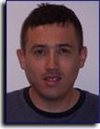 | Camilo Cruz  Camilo graduated with his Bachelor's degree in Electrical Engineering in May '06. Interest/experience: Robotics, Al, Graphics and visual recognition, PC game development, Manufacturing, systems/materials-composites, and Web development.
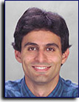 | Dr. Cyril Iskander  Cyril Iskander was an Assistant Professor in FAU's Electrical Engineering Dept. from 2003-2006. He is currently with The MathWork's Signal Processing and Communications Group. His research interests lie with Networks On Chip, Software Radio, Channel Modeling and Simulation, Performance Evaluation of Communication Systems, and Wireless Multimedia. Email: Iskander@fau.edu
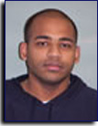 | Ankit Jain  Ankit has received his Master of Science degree in Computer Science in May '06. His thesis focus was "Software Decomposition for Multicore Architectures'. He has also actively researched in Specification Productivity and Component Design Field. He holds SCJP2, CCNA 2.0, A+ certifications. He has worked for Siemens ICN and has been a part of Motorola iDEN division since Jan' 03. Language Experience: C, C++, Java, TTCN, TSL, SQl, PL/SQL, VBS, JavaScript. Research Interests: Networks on Chip, Software Engineering, Concurrency Modeling, Component Flow Design, Reverse Engineering, and Software Decomposition.
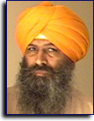 | Baldev Singh Mattu  Baldev has over 22 years of work experience in Telecommunication industry of which the last seventeen years were at Siemens Communication Systems in Boca Raton, FL. Baldev is currently working on the Verification aspects of the OPP Project.
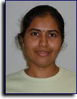 | Vanitha Selvan  Vanitha Selvan pursues her Master's in Computer Science and Engineering at Florida Atlantic University , Boca Raton , FL. She has been working as a research assistant on the OPP project funded by Motorola, since January 2003. Her primary research interest includes developing new methodologies to automate the flow from requirements documents down to code generation using UML, SDL and TTCN languages, and reverse engineering. Her present work involves automatic translation of UML 2.0 concurrent models to SystemC along with developing constraints using Object Constraint Language (OCL).

